Lesson 10
Exponential and Logarithmic Functions

sPECIFIC OBJECTIVES:

At the end of the lesson, the student should be able to :
- Define exponential and logarithmic functions
- Establish the relationship between exponential and logarithmic functions.
- Recall the properties of exponents
- Recall the properties of logarithm.
- Simplify exponential / logarithmic expressions.
- Apply the properties of exponents and logarithm in solving exponential/ logarithmic equations.
- Graph exponential / logarithmic functions.

10.1 Exponential Function
The following properties of exponents are useful in solving exponential functions.
If a and b are positive real numbers, and m and n are rational numbers, then the following properties hold true:

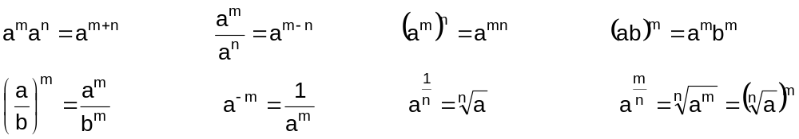

To solve exponential equations, the following property can be used:

Example 10.1.1 Simplify the following:

a) 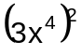 ans. 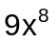

b) 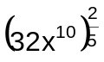 ans. 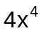

Example 10.1.2 Solve for x:

a) 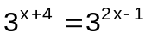 ans. 5

b) 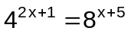 ans. 13

c) 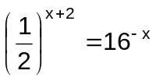 ans. 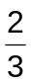

d) 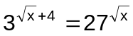 ans. 4

Definition 10.1 Exponential Function

If x and b are real numbers such that b>0 and b1, then f(x) = b^{x} is an exponential function with base b.

Example 10.2.1 The following are examples of exponential functions:

a) 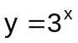 b) 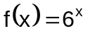 c) 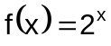

Example 10.2.2 Evaluate the function 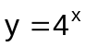 at the given values of x.

a) x = 2 b) x = -3 c) x = 0

10.3 Properties of the Exponential Function y = b^{x}

- The domain is the set of all real numbers.
- The range is the set of positive real numbers.
- The y-intercept of the graph is 1.
- The x-axis is an asymptote of the graph.
- The function is one-to-one.

Example 10.3.1 The graph of the function y = b^{x} .

Domain: 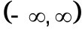 y
Range: 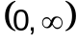
y-intercept: (0,1)
x-intercept: none
Horizontal asymptote: x-axis

--- 1
x

Example 10.3.2 The graph of the function 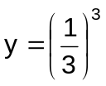 .
y

Domain:
Range:
y-intercept: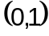
x-intercept: none
Horizontal asymptote: x-axis

__ 1

x

Example 10.3.3 Graph of the following functions:

a) 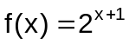 c) 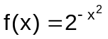

b) 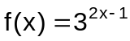 d) 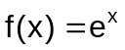

Definition 10.4 Logarithmic Function

For all positive real numbers x and b, b1, the inverse of the exponential function y = b^{x} is the logarithmic function y = log_{b} x.

In symbol, 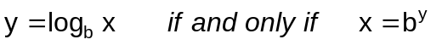

Example 10.4.1 Express in exponential form:

a) 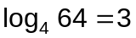 ans. 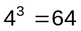

b) 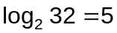 ans. 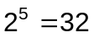

c) 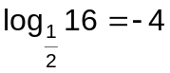 ans. 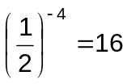

d) 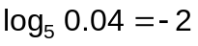 ans. 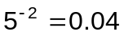

Example 10.4.2 Express in logarithmic form:

a) 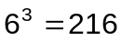 ans. 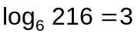

b) 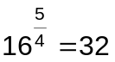 ans. 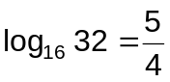

c) 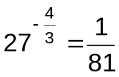 ans. 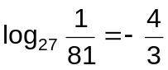

d) 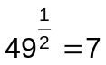 ans. 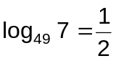

Example 10.4.3 Solve the following:

a) 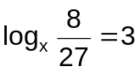 ans. 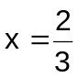

b) 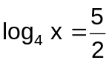 ans. 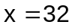

c) 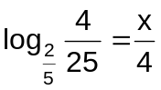 ans. 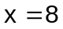

d) 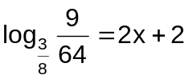 ans. 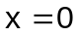

10.5 Properties of the Logarithmic Functions

- The domain is the set of all positive real numbers.
- The range is the set of all real numbers.
- The x-intercept of the graph is 1.
- The y-axis is an asymptote of the graph.
- The function is one-to-one.

Remark:

The graph of 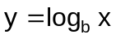 is symmetric to the graph of 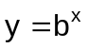 about y = x.

Example 10.5.1 Graph each of the following function:

a) 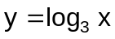 c) 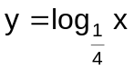

b) 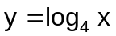 d) 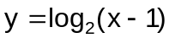

  - Properties of Logarithms

If M, N and b (b1) are positive real numbers, and r is any real number, then

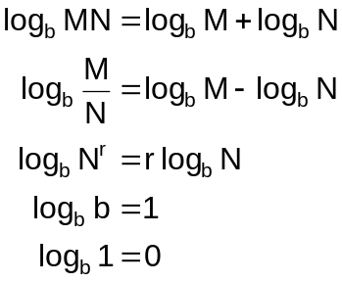

Remark:

Since logarithmic function is continuous and one-to-one, every positive real number has a unique logarithm to the base b. Therefore,

Example 10.6.1 Express the following in expanded form:

a) 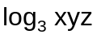 d) 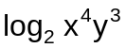

b) 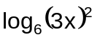 e) 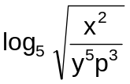

c) 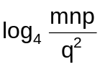

Example 10.6.2 Express as a single logarithm:

a) 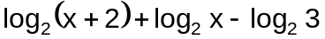

b) 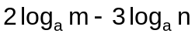

c) 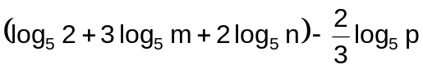
Example 10.6.3 Solve the following:

a) 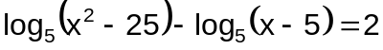 ans. 20

b) 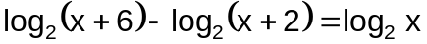 ans. 2

c) 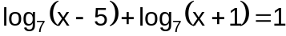 ans. 6

10.7 Natural Logarithm

Natural logarithms are to the base e. The symbol ln x is used for natural logarithms.

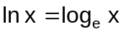

Example 10.7 Solve for x :

a)  ans. 6

  - Change-of- Base Formula

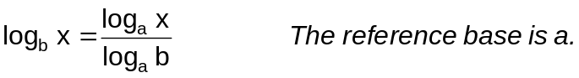

Example 10.8 Use common logarithms to find each logarithm to four decimal places:

a) 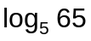 c) 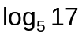

b) 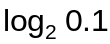 d) 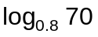

  - Applications: Exponential and Logarithmic Equations

Exponential and logarithmic equations can be used to describe exponential growth and decay, learning curves, logistic growth, etc.

Example 10.9

- The growth rate for a particular bacterial culture can be calculated using the formula 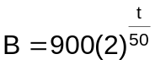, where B is the number of bacteria and t is the elapsed time in hours. How many bacteria will be present after 5 hours?
Ans. 965

- How many hours will it take for there to be 18,000 bacteria present in the culture in example (a)? ans. 216
- A fossil that originally contained 100 mg of carbon-14 now contains 75 mg of the isotope. Determine the approximate age of the fossil, to the nearest 100 years, if the half-life of carbon-14 is 5570 years. (Use the Exponential Decay Formula)

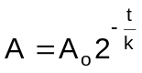 where: A = present amount of isotope
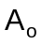 = original amount of isotope
t = time it takes to reduce original
amount of isotope to present amount
k = Half-life of the isotope
ans. 2300

- In a town of 15,000 people, the spread of a rumor that the local transit company would go on strike was such that t hours after the rumor started, f(t) persons heard the rumor, where experience over time has shown that

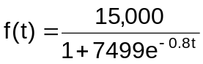
1. How many people started the rumor? Ans. 2
2. How many people heard the rumor after 5 hours? Ans. 108

